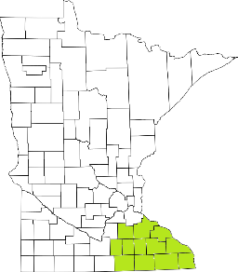Collaborative Resources Education Services Technology
(CREST)
Regional Management Team Agenda
March 12th at
1-3:00 PM
Click here to join the meeting
- Welcome
- TCM Reform
- Crisis Center Update
- Housing
- Transportation
- Training
  - Focus Group May 26th
- Direct Care and Treatment
- Budget
- Updates

Next meeting scheduled for August 11th

