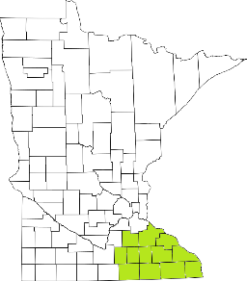Collaborative Resources Education Services Technology
(CREST)
Regional Management Team Agenda
August 11th: 1-3:00 PM
Click here to join the meeting
- Welcome
  - Quick Items
- OBRA Level II
  - DHS presentation and questions
- TCM reform update
  - DHS presentation
- Crisis Center Update
- Strategic planning teams
- Budget
- Agency updates

Next meeting scheduled for November 10th

