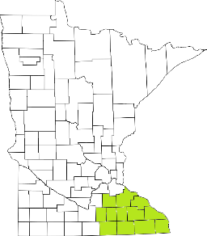Collaborative Resources Education Services Technology
(CREST)
Regional Management Team Agenda
February 10th at 1pm
1-3:00 PM
TEAMS ROOM
- Welcome
- Senior Mental Health (Jane Buffie)
- Wellness in the Woods VPS (Jode Freyholtz-London)
- Regional Management Team restructuring
- Brief Legislative Update
- Budget 21-22
- Updates
  - Impacts of COVID in 2020
    - Community trends
    - Creative solutions

Next meeting scheduled for March

