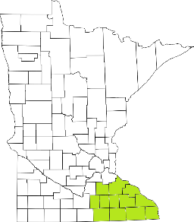Collaborative Resources Education Services Technology
(CREST)
Regional Management Team Agenda
February 9th: Click here to join the meeting
1-3:00 PM
- Welcome
- 988 Updates
- Crisis Services in SE MN
  - 2021 Data
- Prairie Care
  - PHP program
- Training
  - What is next?
- Strategic Planning Work
  - Housing
  - Transportation
- USS:
  - Make sure you’re tuning in!
- 22 Legislative Session
- Updates

Next meeting scheduled for
May 11th, 2022

